**Negative Transformation**

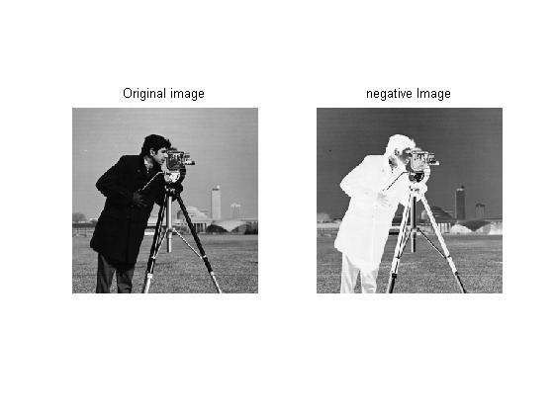

* Image is transformed by transformation function:

b= 256-1-a

where

a is every pixel of original image

b is the new value of every pixel

* As we can see from the image, the lighter pixel becomes dark and darker pixel becomes light. The man’s black coat becomes white while the camera stand legs become black from white.